Debris Compositions

I find myself drawn to objects that have been weathered by natural forces: crumbling bricks, stones softened by the current of a stream, fossils, and kiln yard detritus. These objects served as both environments and inspiration for the vessels that accompany them.

I have chosen to incorporate both architectural remnants and products of nature into these compositions. In so doing, I combine the made and the found, the natural and the manufactured. Signifiers of the “Natural” and the “Human” world are set in relationship, coexisting with one another; all subject to and shaped by the same fundamental forces. Water is present within several of the sculptures and acts as a record of energy. Within the vessel it is made placid, calm, and transient.

In *Debris Composition #1*, the mass and solidity of a broken firebrick is juxtaposed with the precarious balance of the vessel sitting on its edge. The craggy, irregular refractory, eroded by months of exposure to rainfall and other elements, sits delicately within the negative space of the brick. This refractory is paired with a refined vessel containing water. In this way, the force of nature that shaped the found objects is captured and controlled within the sculpture composition.

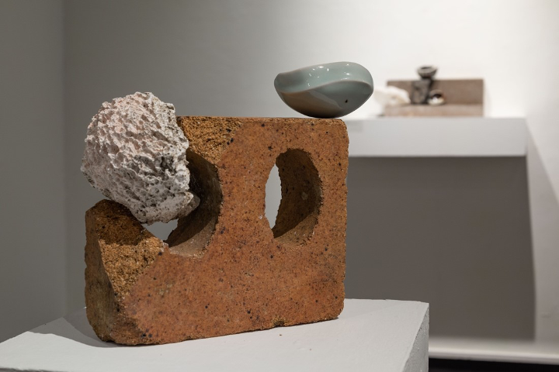

Figure 1. Installation view of *Debris Composition #1* (Photograph by: Tony Irons)

Within *Debris* *Composition #2* a brick, eroded and softened by the running water of a stream, bridges the crumbling structure of the concrete below it. In this sculpture, two like materials respond in dramatically different ways to the eroding force of water. The vessel here responds to the softly eroded texture of the brick, and bears marks that echo the gesture of unearthing the brick from the stream. The sculpture reflects on resilience, structure, support, and time.

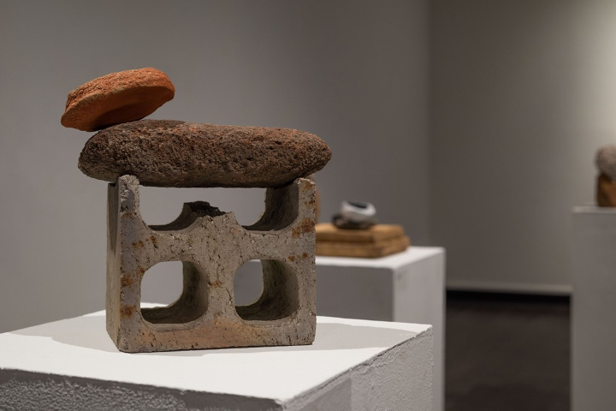

Figure 2. Installation view of *Debris Composition #2* (Photograph by: Tony Irons)

Earth Object Reliquaries

. In the *Earth Object Reliquaries*, outer vessels act as containers for a variety of earth objects. The sculptures resemble a womb, nest, or altar – places of transition and connection. The vessels act as a reliquary for the delicate earth objects contained within, holding, protecting, and preserving them. I have chosen natural and made objects that speak to fundamental human conditions – fragility and resilience, hope and resignation. The need for shelter and care in the pursuit of growth. The vessels act as containers for and embodiments of these concepts.

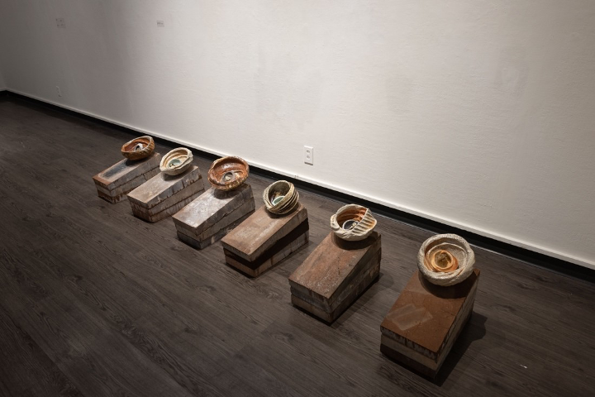

Figure 4. Installation view of *Earth Object Reliquaries* (Photograph by: Tony Irons)

Finger impressions and deep grooves cover the exterior of the reliquaries*,* imparting a human element that contrasts the stark materiality of the vessel. Cracks and fissures that develop in the making of the vessel are left unmarred and incorporated into the design. This allows me to respond intuitively to the qualities of my clay; refining and accentuating the flaws and irregularities that emerge in the making process.

The reliquaries are substantial; heavy, both physically and visually. This gives them a feeling of sturdiness and sheltering quality. They envelop and protect the delicate forms within. Their surface is weathered, bearing the marks of the atmosphere of the kiln and the shadows of the organic materials they were fired with. The heavy battered exterior is contrasted by the delicate vessel contained within. This vessel, itself sheltered within the outer vessel, contains, presents, and preserves their respective object.

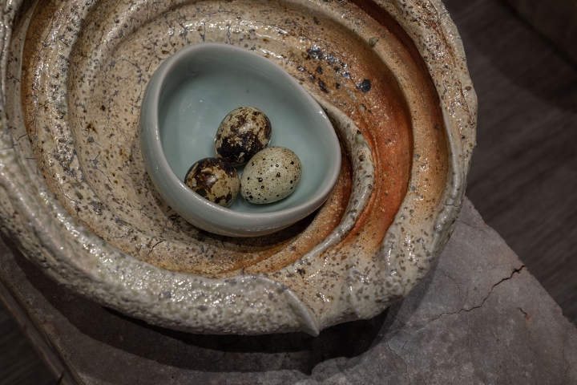

Figure 5. Earth *Object Reliquary* detail (Photograph by: Tony Irons)

Mourning Vessels

Within the installation, shell-like vessels balance on charred wooden pillars, creating a landscape of forms that requires precision and attention to move through. The vessels could be perceived as remnants, or as a thing separated from its other half. They are highly ambiguous – elements of shells, stones, and seeds blend within each vessel. Moving from vessel to vessel; one is extremely refined, minimal in both form and surface, the next is complex with strong lines and varied textures. They are all individual, yet unmistakably related.

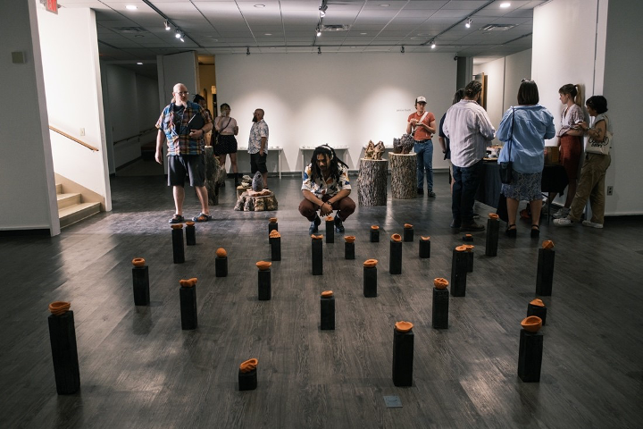

Figure 8. *Stellae Installation* (Photograph by: Tony Irons)

The patient, deliberate, energy of finger pressing into clay can be felt when viewing the work. On the surface of each vessel, fingerprints coalesce into evocative, varied, organic patterns. The shared quality of touch unifies these individuated forms, so too does their shared material language. Each vessel is made from the same iron-rich earthenware clay and decorated with terra sigillata. This results in subtle shifts of tone from piece to piece, as the terra sigillata pools within finger impressions or is burnished on raised edges. When contrasted with the rich, variegated tones of the salt fired vessels, these earthenware vessels feel somber and drained of life.

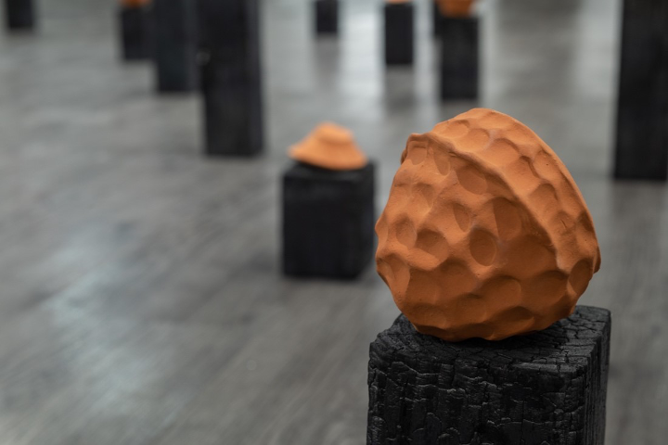

Figure 9. *Stellae Installation* Detail #2 (Photograph by: Tony Irons)

The pillars the vessels rest on are reminiscent of Stelae, monuments which were once used as memorial markers commemorating people or important events. They were believed to delineate physical spaces through which one may access the dead or divine. Within the installation, the pillars serve to separate the vessels physically while pointing towards their commonality. There is a tension in the work between the individuality of each vessel and their role as a part of a larger composition. When viewed individually, each pillar is stark and mournful; viewed collectively, thousands of discrete gestures come together to form a cohesive whole that speaks more to the relationships between the pieces than any individual vessel.

TouchScape

. I decided to create an installation of objects that were made explicitly to be held. I wanted to capture the gesture of a handshake, or of one hand caressing another. My aim was to create a series of objects where that sort of human connection could be felt.

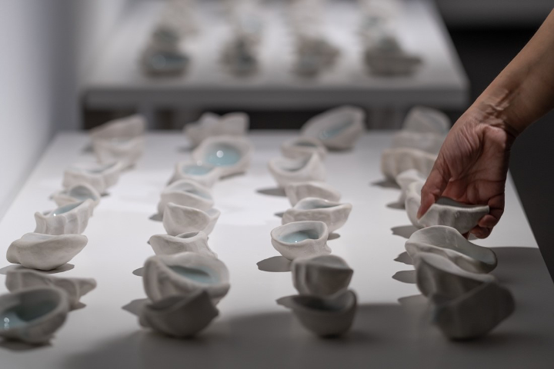

Figure 10. Installation view of *Touchscape* (Photograph by: Tony Irons)

I found that the best way to achieve this was the direct path, holding the clay in my hand and pressing my finger into it to create a very simple vessel. These are perhaps the least “crafted” objects in the show, yet I feel they are among the most deliberate. Their simplicity and naturalness seem to express a confidence that some of the other vessels lack.

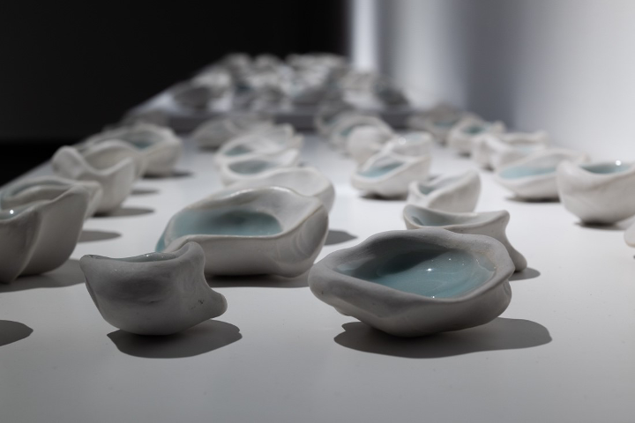

Figure 11. *Touchscape* detail#1 Photograph by: Tony Irons)

I think some part of me wanted to elevate these simple objects. My tendency is to equate labor with value, but these objects were so immediate that they challenged that. It took me some time to come to terms with the fact that this idea wasn’t furthered by pouring more time into each vessel. I wanted them to be delicate, beautiful objects – things that begged to be touched and held. I relied on the seductive qualities of clay and glaze: The gesture of the hand, the brilliance of the porcelain, and the luscious blue of the celadon glaze work in conjunction towards that end.